8-47

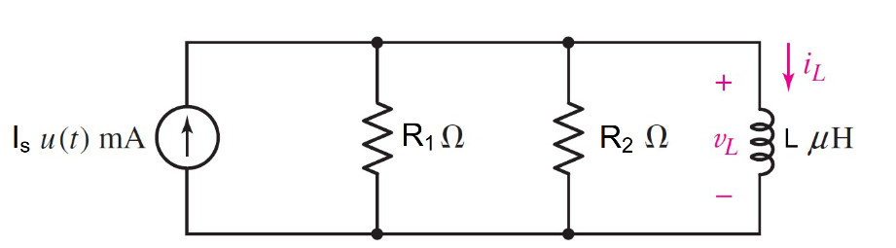

Given R1= 25Ω, R2= 100Ω, L = 3 µH,

Is = 2 *u(t)* mA

Find

Variables (สำหรับเขียนโค้ดเพื่อหาคำตอบ)

Random variables

r1 = {5:30};

r2 = {100:500:50};

l = {1e-3:3e-3:1e-3};

is = {1e-3:5e-3:1e-3};

time = {1:5};

**Global variables**

#is = 0.02; r1 = 25; r2= 100; l = 3*e(-6);

#t<0 t=0-

il0n = 0;

#t>0 t=∞

ilf= is;

# t≥0 t=0+

il0p =il0n;

ir2= (r1/(r1+r2)*is;

vl0p =r2/ir2;

req= r1*r2/r1+r2;

tau = l/req;

ilt = ilf+(il0p-ilf)*exp^(-time);

Part (กรอกคำตอบ)

1. iL(0-)= il0n= 0 ,vL(0-)=0
2. iL(∞)= ilf = 0.002 A
3. vL(0+)= = vl0p=0.04
4. τ =tau = 0.15 µs
5. iL(t) = ilf+(il0p-ilf)*exp^(-t/ tau);= 0.002 -0.002*exp^(-t/ 0.15µ)
6. iL(time*τ*) = ilt =1.26 mA *# time =1*

8-48

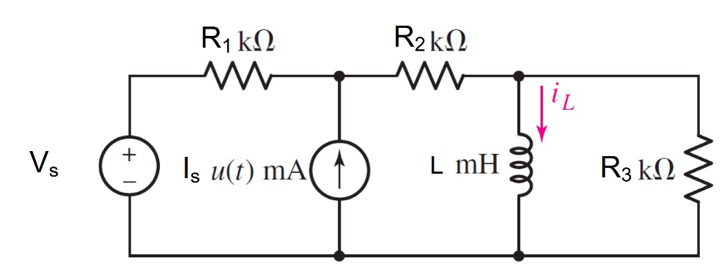

Given R1= 2kΩ, R2= 1kΩ, R3= 1kΩ, L = 10 mH,

Is = 50 *u(t)* mA, Vs = 1.2 V

Find

Variables (สำหรับเขียนโค้ดเพื่อหาคำตอบ)

Random variables

r1 = {1000:2000:100};

r2 = {1000:2000:100};

r3 = {1000:2000:100};

l = {1e-3:20e-3:1e-3};

is = {1e-3:50e-3:1e-3};

vs = {1:5:0.1};

time = {1:5};

**Global variables**

# r1= 2000; r2= 1000; r3= 1000Ω; l = 0.01;

is=0.05 ; vs = 1.2 ;

#t<0 t=0-

il0n = vs/( r1+r2);

#t>0 t=∞

v= r2* (vs + (r1* is))/(r1+r2);

ilf= v/r2;

# t≥0 t=0+

il0p= il0n;

req = (r1+r2)*r3/(r1+r2+r3);

tau = l/req;

ilt = ilf+(il0p-ilf)*exp^(-time);

Part (กรอกคำตอบ)

1. iL(0-)=il0n= 0.0004 A
2. iL(∞)= ilf =0.03373 A
3. τ = tau=1.333 µs
4. iL(t)= ilf+(il0p-ilf)*exp^(-t/ tau) = 0.03373 -0.03333*exp^(-t/1.333µ)
5. iL(time*τ*) = ilt =21.47 mA *# time =1*

8-49

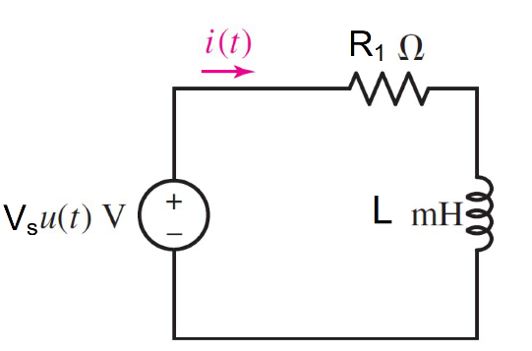

**Given**

R1= 20Ω, L = 45mH, Vs = 2 *u(t)*V

Find

Variables (สำหรับเขียนโค้ดเพื่อหาคำตอบ)

Random variables

r1 = {5:30};

l = {1e-3:50e-3:1e-3};

vs = {1:5};

time = {1:5};

**Global variables**

#vs = 2; r1 = 20;l = 45*e(-3);

#t<0 t=0-

i0n = 0;

#t>0 t=∞

ilf= vs /r1;

# t≥0 t=0+

i0p= i0n;

req = r1;

tau = l/req;

it = ilf+(i0p-ilf)*exp^(-time);

Part (กรอกคำตอบ)

1. i (0-)= i0n=0 A
2. i(∞)= ilf=0.1 A
3. τ = tau=2.25 ms
4. i(t) = ilf+(i0p-ilf)*exp^(-t/ tau) = 0.1 -0.1*exp^(-t/0.00225) A
5. i(time*τ*) = it =63.21 mA *# time =1*

8-50

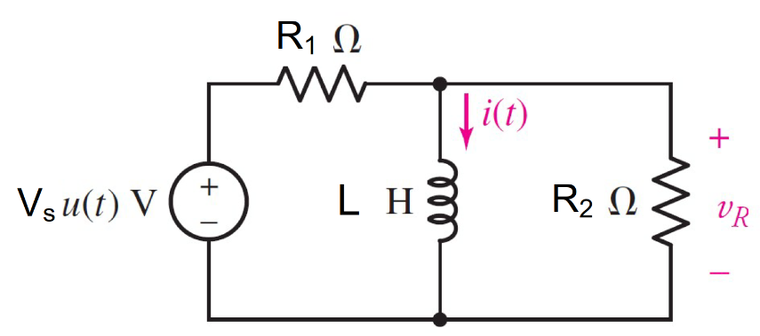

**Given**

R1= 30Ω, R2= 5Ω,L = 5H, Vs = 12 *u(t)*V

Find

Variables (สำหรับเขียนโค้ดเพื่อหาคำตอบ)

Random variables

r1 = {5:30};

r2 = {5:30};

l = {1:5};

vs = {1:15};

time = {1:5};

**Global variables**

#vs =12; r1 = 30; r2= 5; l=5;

#t<0 t=0-

i0n = 0;

#t>0 t=∞

ilf= vs/r1;

# t≥0 t=0+

i0p= i0n;

req = r1*r2/r1+r2;

tau = l/req;

ir2 = vs/(r1+r2);

vr2p = ir2/r2;

it = ilf+(i0p-ilf)*exp^(-time);

Part (กรอกคำตอบ) VR(0+) =vr0p=1.7142 V

1. i(∞)= ilf=0.4 A
2. τ = tau=1.1667s
3. i(t) = ilf+(i0p-ilf)*exp^(-t/ tau)= 0.4 -0.4*exp^(-t/1.1667) A
4. i(time*τ*) = it =63.21 mA *# time =1*

8-51

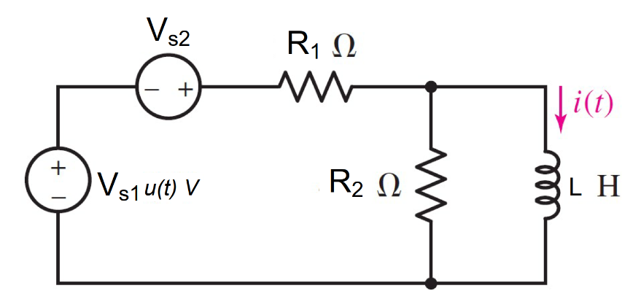

**Given** R1= 100Ω, R2= 400Ω,L = 5H, Vs1 = 6 *u(t)*V, Vs2 = 5 V

Find

Variables (สำหรับเขียนโค้ดเพื่อหาคำตอบ)

Random variables

r1 = {100:1000:100};

r2 = {100:1000:100};

l = {1:5};

vs1 = {1:15};

vs2 = {1:15};

time = {1:5};

**Global variables**

#vs1 =6; vs2 = 5; r1= 100; r2= 400;

l = 5;

#t<0 t=0-

i0n=vs2/r1;

#t>0 t=∞

ilf= (vs1+ vs2)/r1;

# t≥0 t=0+

i0p= i0n;

req = r1*r2/(r1+r2);

tau = l/ req;

it = ilf+(i0p-ilf)*exp^(-time);

Part (กรอกคำตอบ)

1. i(0-)=i0n= 0.05 A
2. i(∞)= ilf=0.11 A
3. τ = tau=0.625s
4. i(t) = ilf+(i0p-ilf)*exp^(-t/ tau)= 0.11 -0.06*exp^(-16t)A
5. i(time*τ*) = it =87.92 mA *# time =1*